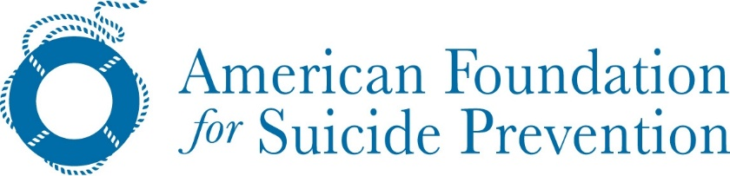
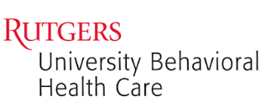

TRAUMATIC LOSS COALITIONS FOR YOUTH

Presents

16th ANNUAL SUICIDE PREVENTION CONFERENCE

Topic: #Social Media & Suicide

Thursday, December 5th, 2019
8:30 am – 3:30 pm

Radisson Hotel Piscataway-Somerset
21 Kingsbridge Road
Piscataway, New Jersey

Supported by

THE AMERICAN FOUNDATION FOR SUICIDE PREVENTION – NEW JERSEY CHAPTER

Cost of Conference: $95.00
Use the link below to register for the conference

https://rutgers.cloud-cme.com/socialmedia&suicide

CONFERENCE TARGET AUDIENCE

TLC Coalition Members & Coordinators - Mental Health Clinicians - School Counselors
School Resource Officers – Educators - School Administrators - School Psychologists - School Nurses
Division of Family Services Personnel – Certified Counselors – Social Workers - Juvenile Justice Personnel
Law Enforcement Personnel – Clergy - Substance Abuse Counselors - Child and Adult Psychiatrists Pediatricians –Parents

TRAUMATIC LOSS COALITIONS FOR YOUTH
Program funding is provided the New Jersey Department of Children & Families, Division of Family and Community Partnerships, Office of School Linked Services in partnership with Rutgers University Behavioral Health Care.

151 Centennial Avenue, Piscataway, NJ 08854

http://ubhc.rutgers.edu/tlc/
732-235-2810

CONFERENCE KEYNOTE SPEAKER

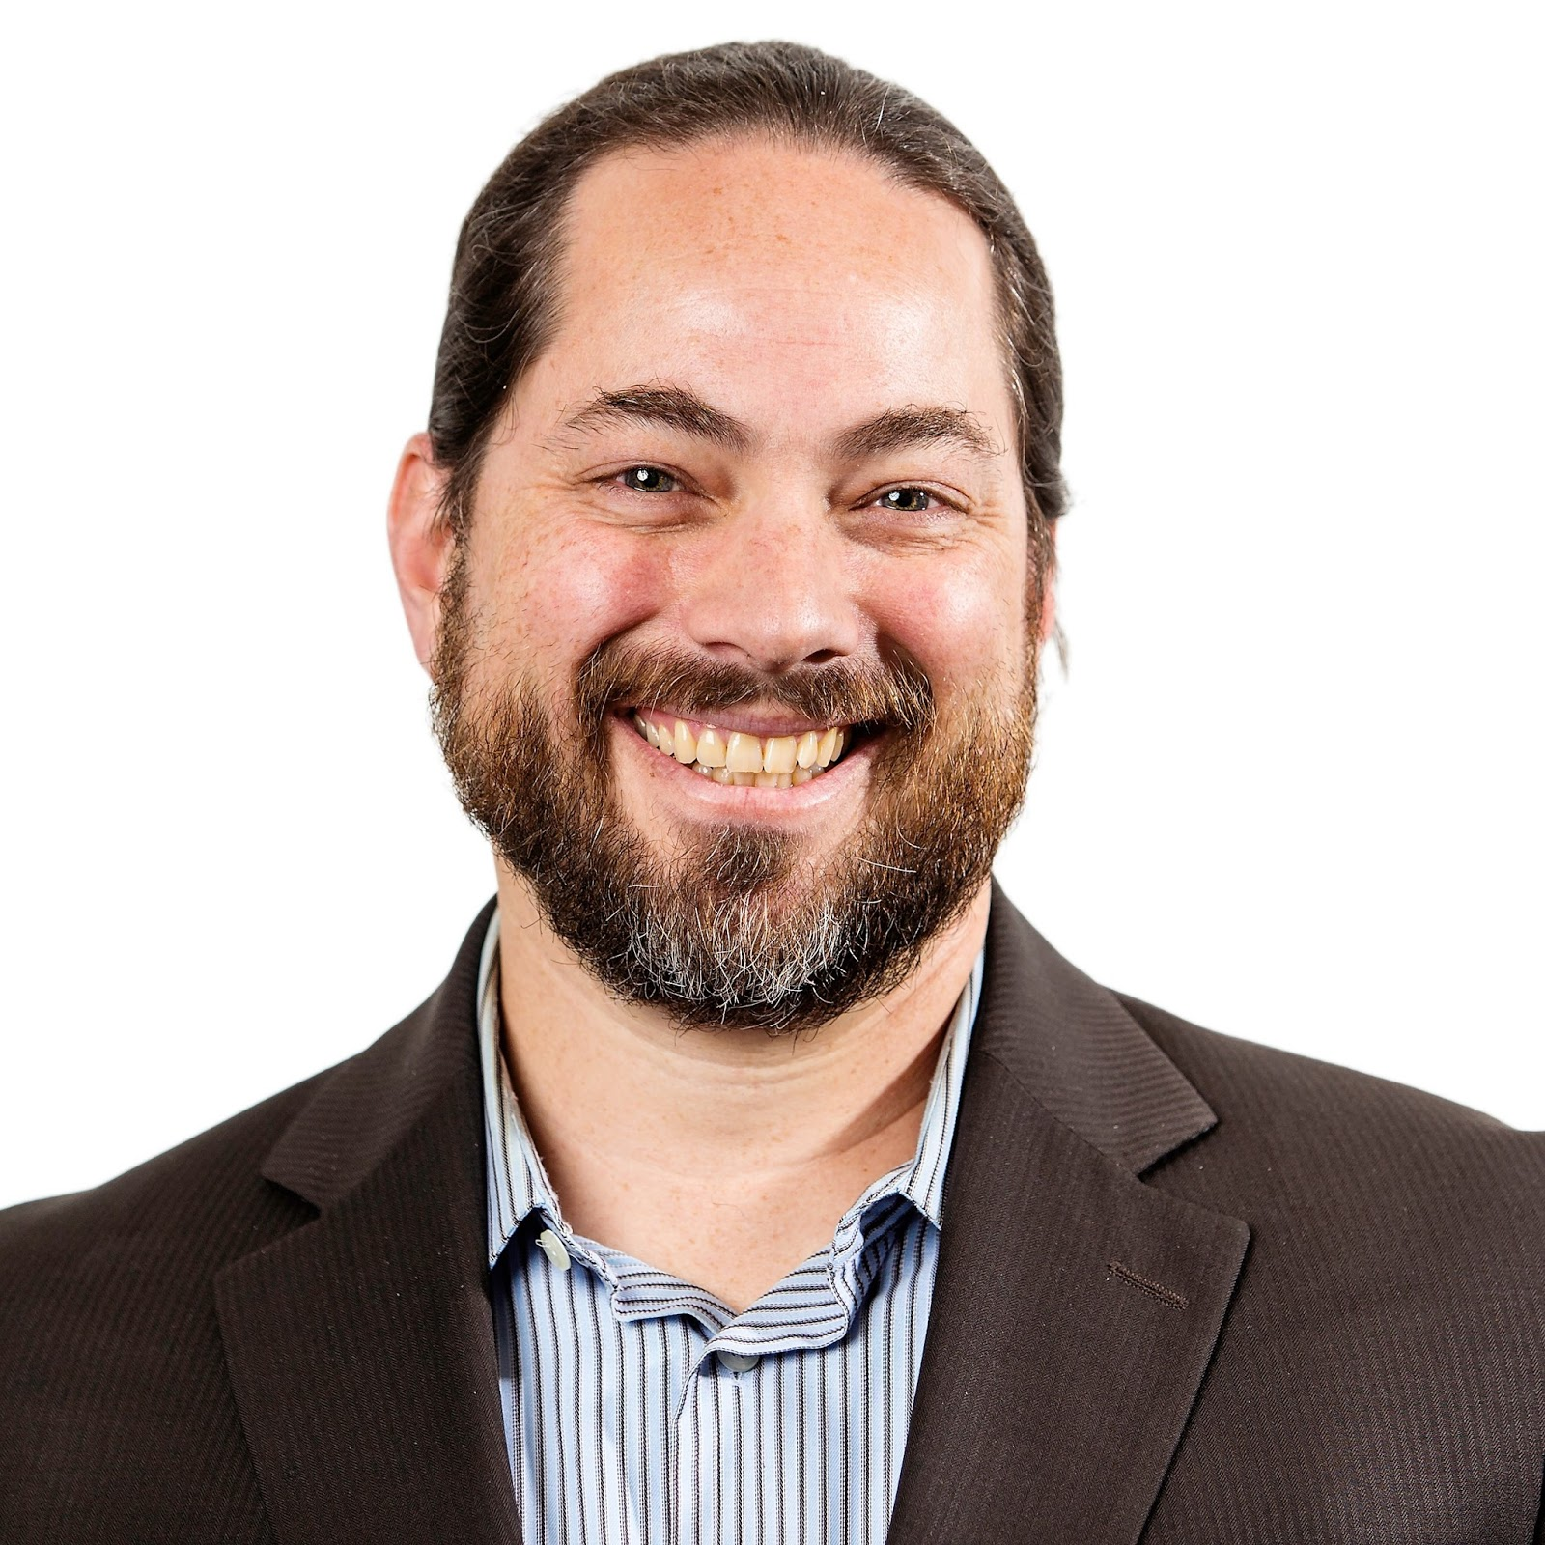

Jonathan B. Singer, Ph.D., LCSW
Associate Professor, School of Social Work
Loyola University Chicago
President, American Association of Suicidology
Founder and Host of the Social Work Podcast

Program Agenda

8:00 AM – 8:30 AM | Conference Sign-In
8:30 AM – 8:35 AM | Welcome & Conference Overview  Maureen A. Brogan, LPC, ACS, DRCC  Program Manager, Traumatic Loss Coalitions for Youth Program
8:35 AM – 8:50 AM | Opening Remarks  The Importance of Having Conversations to Combat this Public Health Issue  Frank Ghinassi, PhD, ABPP  President & CEO, Rutgers University Behavioral Health Care
8:50 AM – 9:00 AM | What Are We Doing In NJ to Keep the Conversation Going?  Wendy Sefcik  Chair, Youth Suicide Advisory Council
9:00 AM – 11:30 AM | Where is Technology in the Efforts to Reduce Suicide?  - Utilizing and Measuring the Effectiveness of Suicide Prevention Apps  - Social Media Safety  Jonathan Singer, Ph.D, LCSW  Associate Professor, School of Social Work  Loyola University Chicago  President, American Association of Suicidology
11:30 AM – 12:30 PM | Lunch
12:30 PM – 12:40 PM | Presentation of the 2019 Youth Suicide Prevention Excellence Award  Karen Dunne-Maxim, MS, RN
12:40 PM – 2:00 PM | Symbols & the Future of Therapy  Jonathan Singer, Ph.D, LCSW
2:00 PM – 2:10 PM | Break
2:10 PM – 3:10 PM | Creating Resilience Through Social-Emotional Learning  Erin Bruno-Hugel, MA  Coordinator, Social Decision Making  University Behavioral Health Care, Rutgers, The State University
3:10 PM – 3:30 PM | Questions & Answers, Evaluations, & Adjournment
If a participant or potential participant would like to express a concern about their experience with the Rutgers University Behavioral health Care activity, they may e-mail the Center for Continuing Education at cce@ubhc.rutgers.edu.

All individuals who affect the content of continuing education activities are required to disclose to the audience any real or apparent conflict of interest related to the activity. The activity faculty is further required to disclose the discussion of off-label/investigational uses in their presentations. These disclosures will be made at the time of the activity. There is no commercial support for this activity.

Professional Contact Hours
To receive documentation for continuing education, all participants must:
- Arrive on time, sign in, and be present for the entire session.
- Participants must sign-in before the beginning and complete the online program evaluation (instructions are below).
- Partial credits will not be issued to participants arriving late or leaving early.

To receive CE Credit for attending this course you must complete the program evaluation. Please follow the below instructions.

- You will receive an email from Rutgers University, please visit https://rutgers.cloud-cme.com . Sign in using the e-mail submitted on your sign in sheet.

- Click “My CE” to complete your profile—Make sure to select “General Attendance” along with any other credit types that pertain to your degree/licensure.

- In the "My CE" portal, you will then be able to click "Evaluations and Certificates" and complete your evaluation for the event.

- You must fill out every mandatory field (noted in red) to submit the evaluation. If you click "submit" and nothing happens, please scroll back up to see which field was not completed

- After submitting the evaluation, you will be able to download or email a PDF of your CE Certificate.

- After completing the course evaluation in the rutgers.cloud-cme system, your CE Certificate will be emailed to you. Your CE Certificate will also be available for download in the system for 3 months following the program.

- If you get stuck, call us at (732) 235-9282 or email CCE@ubhc.rutgers.edu .

Here’s a video if you need help: https://youtu.be/bK308vJeCeI

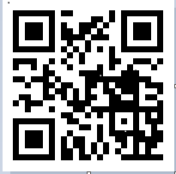

In support of improving patient care, Rutgers Biomedical and Health Sciences is jointly accredited by the Accreditation Council for Continuing Medical Education (ACCME), the Accreditation Council for Pharmacy Education (ACPE), and the American Nurses Credentialing Center (ANCC), to provide continuing education for the healthcare team.
Nurses: This activity is awarded 5.5 contact hours (60 min CH)
Educators: Educators may receive credit for 5.5 Professional Development Hours. There is no charge for this certificate.
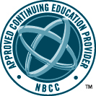
Certified Counselors: Rutgers University Behavioral Health Care has been approved by NBCC as an Approved Continuing Education Provider, ACEP No. 6198. Programs that do not qualify for NBCC credit are clearly identified. Rutgers University Behavioral Health Care is solely responsible for all aspects of the program. 5.5 Clock Hours
Psychologists: Rutgers University Behavioral Health Care is approved by the American Psychological Association to sponsor continuing education for psychologists. Rutgers University Behavioral Health maintains responsibility for the program and its content. Instructional Level: Introductory. 5.5 CE Credits
Screener Recertification: In compliance with Rutgers University Behavioral Health Care-Technical Assistance Center (TAC) policy, 6.0 full TAC Continuing Education Credits will be issued only to Screeners who attend the entire scheduled class.
Social Workers (The New Jersey Board of Social Work Examiners): This program is approved for social work continuing education hours by Rutgers University Behavioral Health Care in accordance with New Jersey administrative code 13:44G-6.4 and recognized by The New Jersey Board of Social Work Examiners. This program has been approved for 6.5 General Continuing Education Credit Hours.

